Docker Basics to create a .Net Image

## Building a simple dockerfile for .net core project

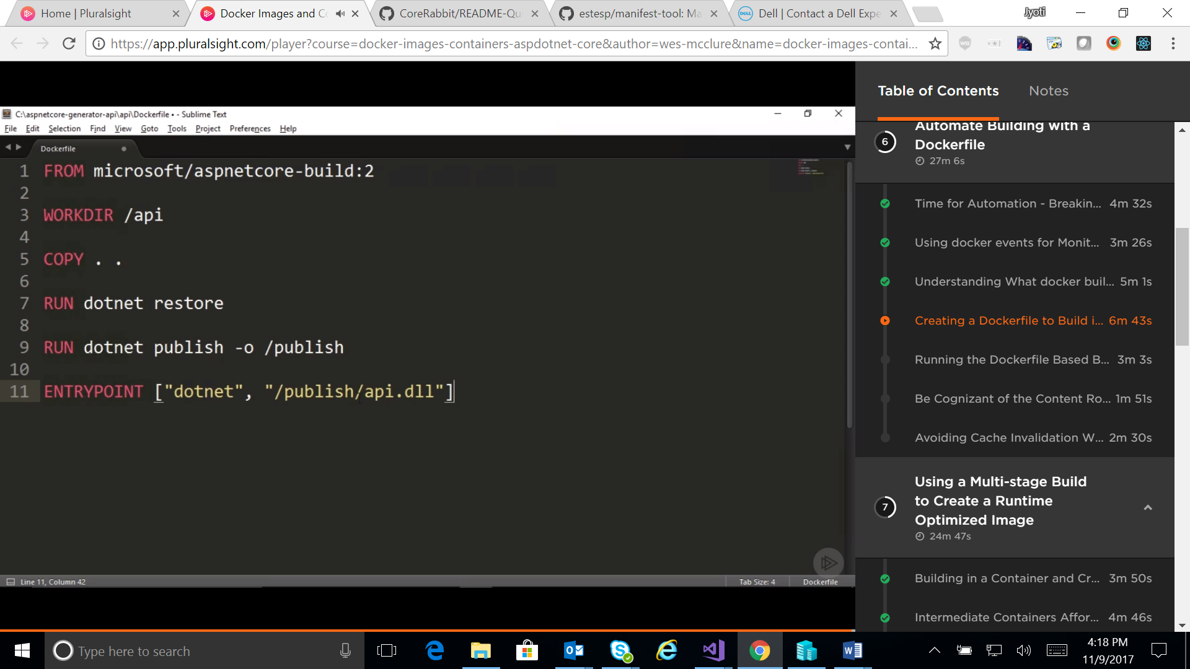

And, edit the .dockerignore file as following:

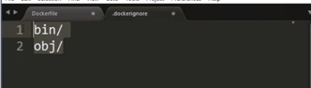

Now, run the following command:



Run the following command to use host port for your application:

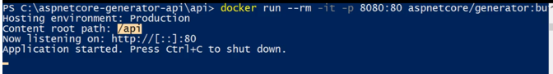

And now the API project should be operational, in general.

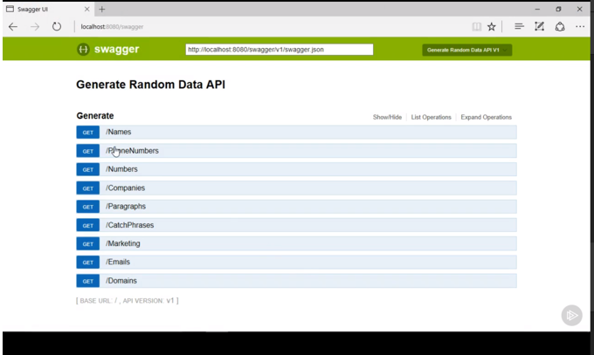

## Important to note:

In above example, *content root path* is showing as */API*, even though publish folder is */publish*.

It comes from following code template of core 2:

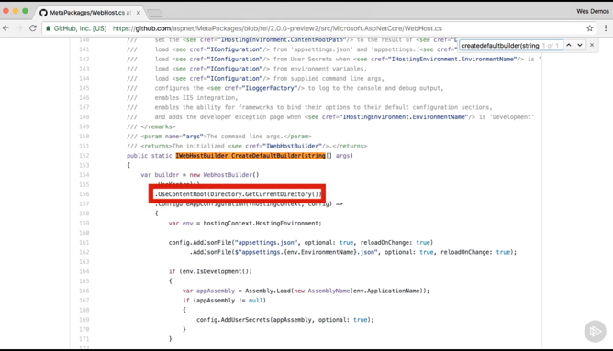

Edit the dockerfile as following:

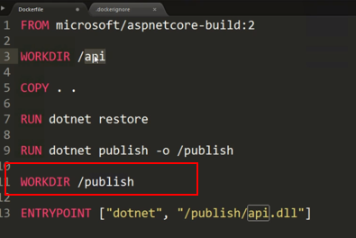

Run the docker build command again:



But it won’t use cache from instruction line(even though no code has changed) COPY . . .

Reason for that is that dockerfile content itself has changed and it’s in the same folder that was being copied. To avoid that, add the Dockerfile to .dockerignore file as following:

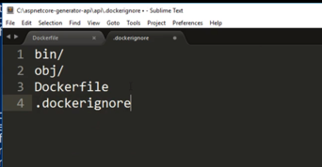

Run the build command all over again so that cache is used:



See cache being used for each instruction:

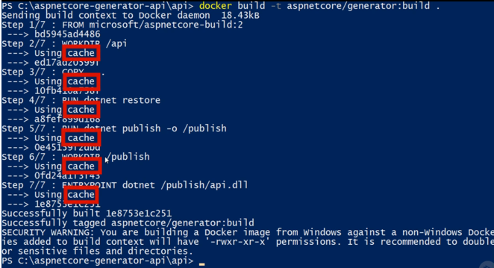

Also notice in above screen shot, at step 6/7, our change of *workdir* has worked which shall be verified in next command whether *content path* is set correctly or not.

